LCD based digital alarm clock with digital thermometer using 8051 microcontroller (AT89C51)
MC031
- Summary
- Description
- Circuit Diagram
- Video
- Code
- Components
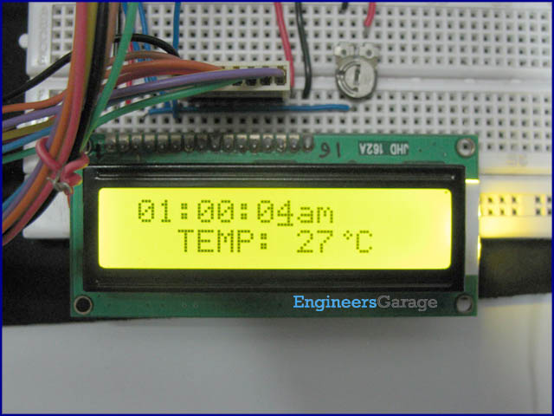
This project works as a digital clock wherein a user can also set alarm. Additionally, it also works as a digital thermometer to specify the ambient temperature. Both, the clock and temperature are displayed on a 16x2 LCD screen using the 8051 microcontroller (AT89C51). AT89C51 is an eight bit controller which belongs to the 8051 family of microcontrolers.

This project incorporates the functionality of a digital clock and a digital thermometer. The digital clock works in 12 hour mode and is configured by programming the 8051 microcontroller (AT89C51). The program uses a delay function for producing a delay of 1 second. The clock and alarm times can be set through a set of external tactile switches.
The digital thermometer employs a temperature sensor LM35. The sensor responds to the temperature change by giving varying output. These analog signals of LM35 are converted to digital equivalent by ADC0804. The reference voltage (V_{ref}) should be set properly corresponding to the desired temperature range. The data bits are taken as input by the microcontroller at port P0. The microcontroller AT89C51 also gives control signals to ADC0804.
// Program to make a digital clock with integrated Alarm and digital thermometer
#include<reg51.h>
#define port P1
#define adc_input P0
#define cont_port P3
#define dataport P2
#define m_sec 10

sbit rs = cont_port^0;
sbit rw = cont_port^1;
sbit en = cont_port^6;
sbit dig_hr1=port^0;
sbit dig_min1=port^1;
sbit start=port^2;
sbit am_pm=port^3;
sbit alarm_set=port^4;
sbit alarm=port^7;
sbit wr= P3^2;
sbit rd= P3^3;
sbit intr= P3^4;

int hr ,hr1=0,alarm_hr=0;
int min,min1=0,alarm_min=0;
int sec,sec1=0,dig_am_pm=0,alarm_am_pm=0;
int test_final=0,test_intermediate1[10],test_intermediate2[3]={0,0,0};

void delay(unsigned int msec) // Time dealy function
{
int i,j ;
for(i=0;i<msec;i++)
for(j=0;j<1275;j++);
}

void lcd_cmd(unsigned char item) //Function to send command to LCD
{
dataport = item;
rs= 0;
rw=0;
en=1;
delay(1);
en=0;
return;
}

void lcd_data(unsigned char item) // Function to send data to LCD
{
dataport = item;
rs= 1;
rw=0;
en=1;
delay(1);
en=0;
return;
}

void lcd_data_string(unsigned char *str) // Function to send string to LCD
{
int i=0;
while(str[i]!='\0')
{
lcd_data(str[i]);
i++;
delay(1);
}
return;
}

lcd_data_int(int time_val) // Function to send number to LCD
{
int int_amt;
int_amt=time_val/10;
lcd_data(int_amt+48);
int_amt=time_val%10;
lcd_data(int_amt+48);
return;
}

void lcd(unsigned char str1[10])
{
lcd_cmd(0x38);
lcd_cmd(0x0e);
delay(1);
lcd_data_string(str1);
}

void shape() // Function to create the shape of degree
{
lcd_cmd(64);
lcd_data(2);
lcd_data(5);
lcd_data(2);
lcd_data(0);
lcd_data(0);
lcd_data(0);
lcd_data(0);
lcd_data(0);
}

void convert() // Function to convert the data of ADC
{
int s;
s=test_final/100;
test_final=test_final%100;
lcd_cmd(0xc9);
if(s!=0)
lcd_data(s+48);
else
lcd_cmd(0x06);
s=test_final/10;
test_final=test_final%10;
lcd_data(s+48);
lcd_data(test_final+48);
lcd_data(0);
lcd_data('C');
lcd_data(' ');
delay(2);
}

void set_hr1() // Function to set set hours digit of clock
{
hr1++;
if(hr1>11)
hr1=0;
lcd_cmd(0xc3);
lcd_data_int(hr1);
lcd_data(':');
}

void set_min1() // Function to set set minutes digit of clock
{
min1++;
if(min1>59)
min1=0;
lcd_cmd(0xc6);
lcd_data_int(min1);
}

void set_alarm_hr1() // Function to set set hours digit of alarm
{
alarm_hr++;
if(alarm_hr>11)
alarm_hr=0;
lcd_cmd(0xc3);
lcd_data_int(alarm_hr);
lcd_data(':');
}

void set_alarm_min1() // Function to set set minutes digit of clock
{
alarm_min++;
if(alarm_min>59)
alarm_min=0;
lcd_cmd(0xc6);
lcd_data_int(alarm_min);
}

void alarm_check() // Function to check alarm
{
if(hr==alarm_hr)
{
if(min==alarm_min)
{
if(dig_am_pm==alarm_am_pm)
{
alarm=1;
lcd_cmd(0x8b);
lcd("ALARM");
}
}
}
}

void temp() // Function to calculate temperature
{
int i;
for(i=0;i<10;i++)
{
delay(1);
rd=1;
wr=0;
delay(1);
wr=1;
while(intr==1);
rd=0;
lcd_cmd(0x88);
test_intermediate1[i]=adc_input/10;
delay(1);
intr=1;
}
for(i=0;i<10;i++)
test_intermediate2[0]=test_intermediate1[i]+test_intermediate2[0];
for(i=0;i<10;i++)
{
delay(1);
rd=1;
wr=0;
delay(1);
wr=1;
while(intr==1);
rd=0;
lcd_cmd(0x88);
test_intermediate1[i]=adc_input/10;
delay(1);
intr=1;
}
for(i=0;i<10;i++)
test_intermediate2[1]=test_intermediate1[i]+test_intermediate2[1];
for(i=0;i<10;i++)
{
delay(1);
rd=1;
wr=0;
delay(1);
wr=1;
while(intr==1);
rd=0;
lcd_cmd(0x88);
test_intermediate1[i]=adc_input/10;
delay(1);
intr=1;
}
for(i=0;i<10;i++)
test_intermediate2[2]=test_intermediate1[i]+test_intermediate2[2];
test_intermediate2[0]=test_intermediate2[0]/3;
test_intermediate2[1]=test_intermediate2[1]/3;
test_intermediate2[2]=test_intermediate2[2]/3;
test_final=test_intermediate2[0]+test_intermediate2[1]+test_intermediate2[2];
shape();
convert();
}

void main()
{
int k;
start=1;
dig_hr1=1;
dig_min1=1;
alarm_set=1;
alarm=0;
lcd_cmd(0x83);
lcd("SET ALARM");
lcd_cmd(0xc3);
lcd_data_int(hr1);
lcd_data(':');
lcd_data_int(min1);
while(alarm_set==0)
{
delay(10);
if(dig_hr1==0)
set_alarm_hr1();
if(dig_min1==0)
set_alarm_min1();
}

if(am_pm==0)
{
lcd_cmd(0xc8);
lcd_data_string("am");
alarm_am_pm=0;
}

if(am_pm==1)
{
lcd_cmd(0xc8);
lcd_data_string("pm");
alarm_am_pm=1;
}
delay(200);
lcd_cmd(0x01);
lcd_cmd(0x83);
lcd("SET TIMING");
lcd_cmd(0xc3);
lcd_data_int(hr1);
lcd_data(':');
lcd_data_int(min1);
while(start==0)
{
delay(10);
if(dig_hr1==0)
set_hr1();
if(dig_min1==0)
set_min1();
}

if(am_pm==0)
{
lcd_cmd(0xc8);
lcd_data_string("am");
dig_am_pm=0;
}

if(am_pm==1)
{
lcd_cmd(0xc8);
lcd_data_string("pm");
dig_am_pm=1;
}
delay(200);
lcd_cmd(0x01);
while(1)
{
for(k=0;k<2;k++)
{
for(hr=hr1;hr<12;hr++)
{
for(min=min1;min<60;min++)
{
for(sec=0;sec<60;sec++)
{
lcd_cmd(0x81);
delay(1);
lcd_data_int(hr);
lcd_data(':');
lcd_data_int(min);
lcd_data(':');
lcd_data_int(sec);
if(dig_am_pm==0)
{
lcd("am");
}
else
{
lcd("pm");
}
alarm_check();
lcd_cmd(0xc3);
delay(2);
lcd_data_string("TEMP:");
temp();
lcd_data_string(" ");
}
}
min1=0;
}
if(dig_am_pm==0)
dig_am_pm=1;
else
dig_am_pm=0;
hr1=0;
}
}
}
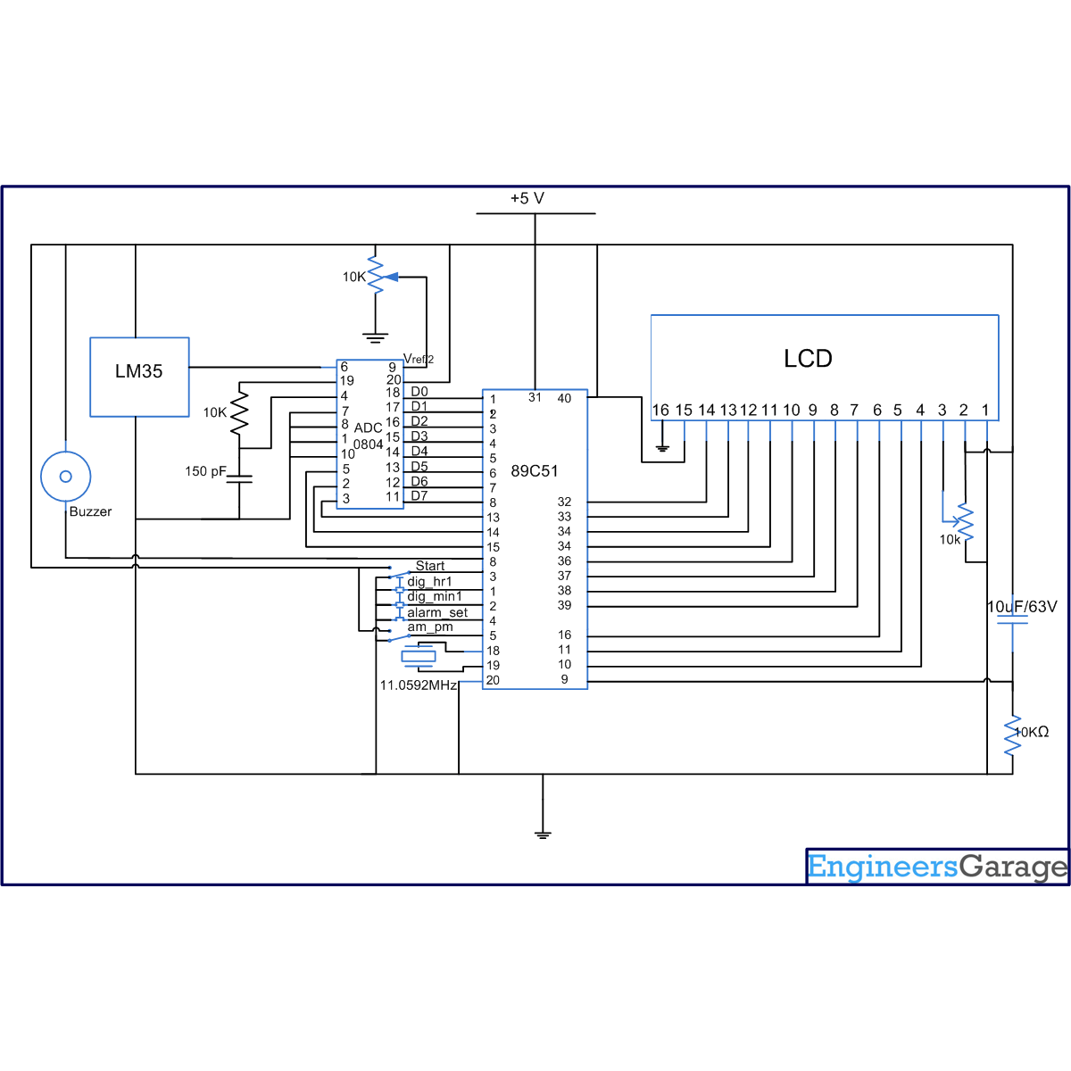
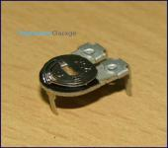
- 11,769-Reads
Preset

A preset is a three legged electronic component which can be made to offer varying resistance in a circuit. The resistance is varied by adjusting the rotary control over it. The adjustment can be done by using a small screw driver or...
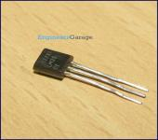
- 8,568-Reads
LM35 Temperature Sensor
LM35 is a precision IC temperature sensor with its output proportional to the temperature (in ºC). The sensor circuitry is sealed and therefore it is not subjected to oxidation and other processes. With LM35, temperature can be measured more accurately than with a thermistor. It also possess low self heating and does not cause more than 0.1 ºC temperature rise...
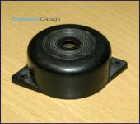
- 5,454-Reads
Piezo Buzzer

The piezo buzzer produces sound based on reverse of the piezoelectric effect. The generation of pressure variation or strain by the application of electric potential across a piezoelectric material is the underlying principle....
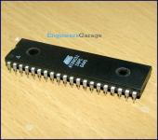
- 38,656-Reads
AT89C51 Microcontroller
AT89C51 is an 8-bit microcontroller and belongs to Atmel's 8051 family. AT89C51 has 4KB of Flash programmable and erasable read only memory (PEROM) and 128 bytes of RAM. It can be erased and program to...
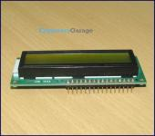
- 23,904-Reads
LCD

LCD (Liquid Crystal Display) screen is an electronic display module and find a wide range of applications. A 16x2 LCD display is very basic module and is very commonly used in various devices and circuits. These modules are preferred over seven segments...
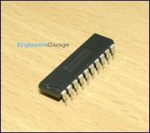
- 12,619-Reads
ADC0804
Analog to digital converters find huge application as an intermediate device to convert the signals from analog to digital form. These digital signals are used for further processing by the digital processors. Various sensors like temperature, pressure, force etc. convert the physical characteristics into electrical signals that are analog in nature....

